# UK Box Office Analysis: 30 May–1 June 2025

Prepared by: Austin Mofokeng Matlepe  
Date: 06 June 2025  
Tools Used: Microsoft Excel, Microsoft Power BI

## Table of Contents

1. Executive Summary
2. Data Cleaning (Excel)
3. Exploratory Data Analysis (Excel)
4. Visualizations & Insights (Power BI)
5. Key Insights & Recommendations
6. Reflection
7. Appendix

## 1. Executive Summary

This project analyzes the BFI Weekend Box Office report for 30 May–1 June 2025. The goal was to clean, analyze, and visualize UK box office data to extract actionable insights for film distributors and industry stakeholders. Using Excel for data cleaning and Power BI for advanced visualization, the analysis highlights top-performing films, country trends, and market diversity.

## 2. Data Cleaning (Excel)

Process:

* Removed non-film rows (totals, notes, section headers).
* Standardized columns: Rank, Film, Country of Origin, Weekend Gross, Distributor, % Change, Weeks on Release, Number of Cinemas, Site Average, Total Gross to Date.
* Ensured all numeric columns were formatted as numbers.
* Addressed missing or inconsistent data by removing or clarifying ambiguous entries.

Screenshot Example: The data before it was cleaned  
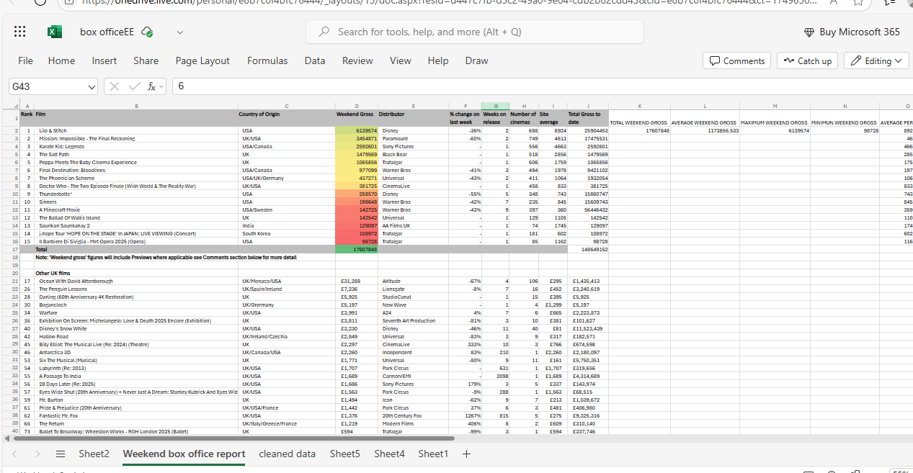

Result:

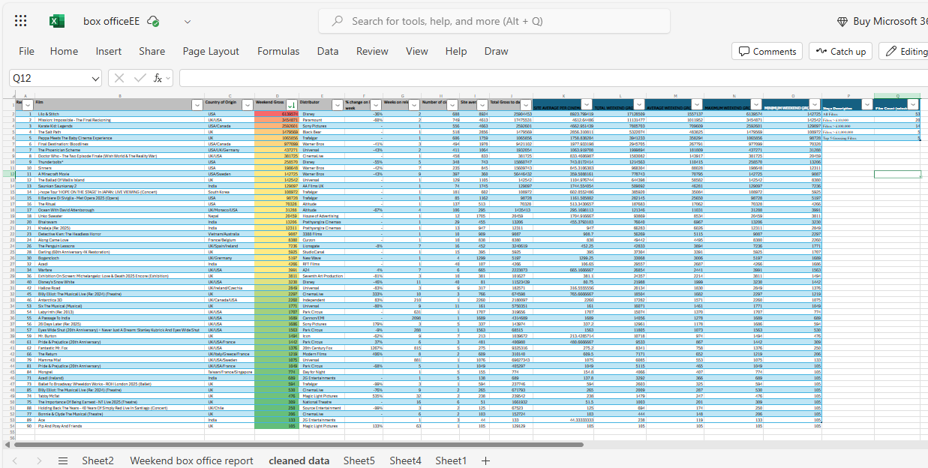  
A clean dataset of 43 films with all relevant metrics, ready for analysis.

## 3. Exploratory Data Analysis (Excel)

Key Calculations:

* Total number of films: 53
* Total weekend gross: £17,834,206
* Average weekend gross: £409,485
* Top 5 films by weekend gross:
  + Lilo & Stitch (£6,139,574)
  + Mission: Impossible - The Final Reckoning (£3,454,871)
  + Karate Kid: Legends (£2,592,601)
  + The Salt Path (£1,479,569)
  + Peppa Meets the Baby Cinema Experience (£1,065,856)
* Films by country:
  + UK: 21
  + USA: 12
  + Others: 10

Screenshot Example:  
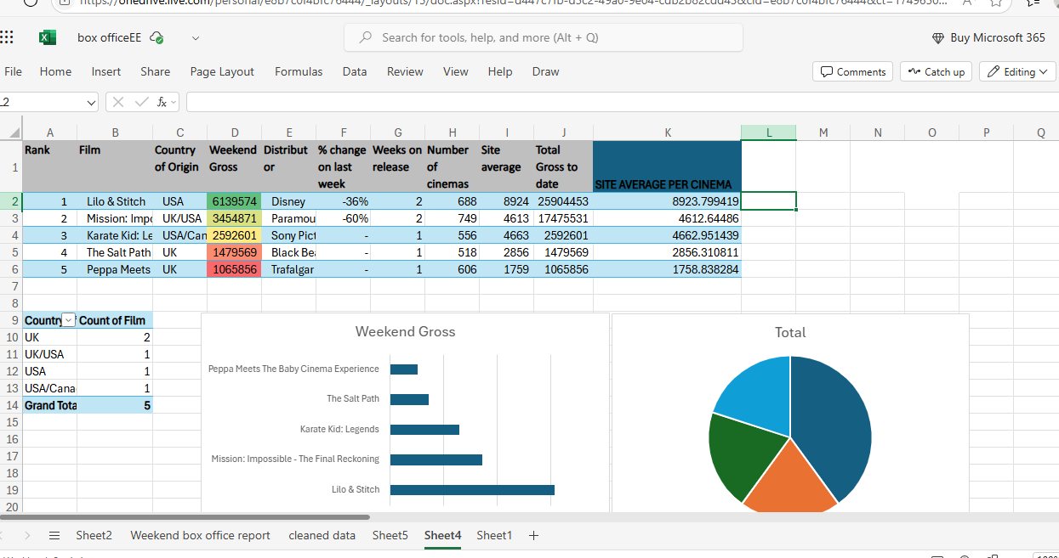

## 4. Visualizations & Insights (Power BI)

## A. Top 5 Grossing Films (Bar Chart)

* Insight: "Lilo & Stitch" led the box office with £6.1M, showing strong family appeal.

## B. Films by Country of Origin (Pie Chart)

* Insight: UK films were the most numerous, reflecting a robust domestic industry.

## C. Total Weekend Gross (Card)

* Insight: The total weekend gross across all films was £17.6M.

## D. Full Film List (Table)

* Insight: Allows detailed comparison of all metrics per film.

## E. Film Count Funnel (Funnel Chart)

* Stages:
  + All Films: 43
  + Films > £10,000: 20
  + Films > £100,000: 14
  + Films > £1,000,000: 5
  + Top 5 Grossing Films: 5
* Insight: Only a small fraction of films achieve blockbuster status.

## F. Cinemas vs. Weekend Gross (Scatter Plot)

* Insight: Films with wide releases don’t always have the highest site averages, highlighting the value of targeted distribution.

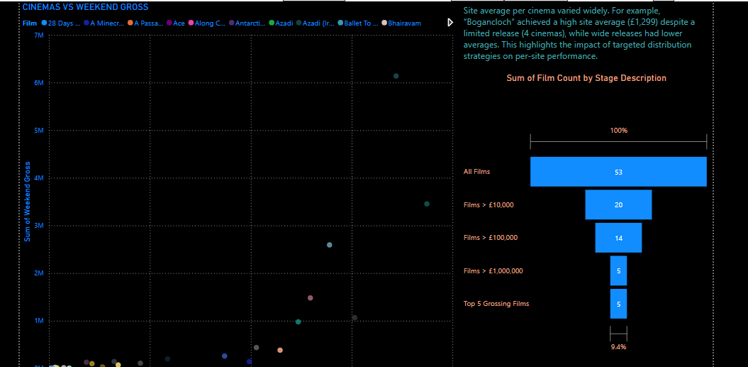

## 5. Key Insights & Recommendations

* Top Film: "Lilo & Stitch" dominated the weekend, confirming the continued popularity of family films.
* Country Representation: UK films led in quantity, but US and co-productions captured significant box office share.
* Outliers: "Bogancloch" achieved a high site average (£1,299) despite a very limited release, suggesting the potential of niche targeting.
* Market Diversity: The box office featured a mix of blockbusters, indie films, re-releases, and event screenings.
* Recommendations:
  + Distributors should consider limited releases for niche films to maximize site averages.
  + Continued investment in family and legacy content is likely to yield strong returns.
  + Monitor performance of re-releases and event cinema for alternative revenue streams.

## 6. Reflection

This project enhanced my skills in data cleaning, exploratory analysis, and visualization. I learned the importance of clear data structure and the value of combining Excel and Power BI for end-to-end analytics. Next steps could include automating data updates or exploring predictive analytics for box office trends.

## 7. Appendix

* Cleaned Excel file: *bfi-weekend-box-office-report-2025-05-30-06-01-2.xlsx*
* Power BI file: *box_office_dashboard.pbix*
* Additional screenshots and pivot tables